Architecture and Design

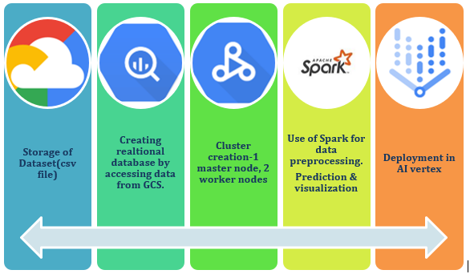
We have followed the above architectural design for predicting cardiovascular disease (CVD) using Hadoop. The design includes:
- Data collection and loading into Cloud Platform
- Preprocessing in Spark
- Analysis in Spark
- Feature engineering
- Model training using SparkML
- Prediction
- Deployment in Google AI vertex
The aim is to build an accurate machine learning model using distributed processing frameworks that can be integrated with Hadoop and deployed using an API.
The design emphasizes the importance of data quality and feature selection to improve model accuracy and performance.

